INF 552 Homework 1 Report

Author: Nelson Lam

Due Date: Sept 17, 2019

(b) i. + ii.

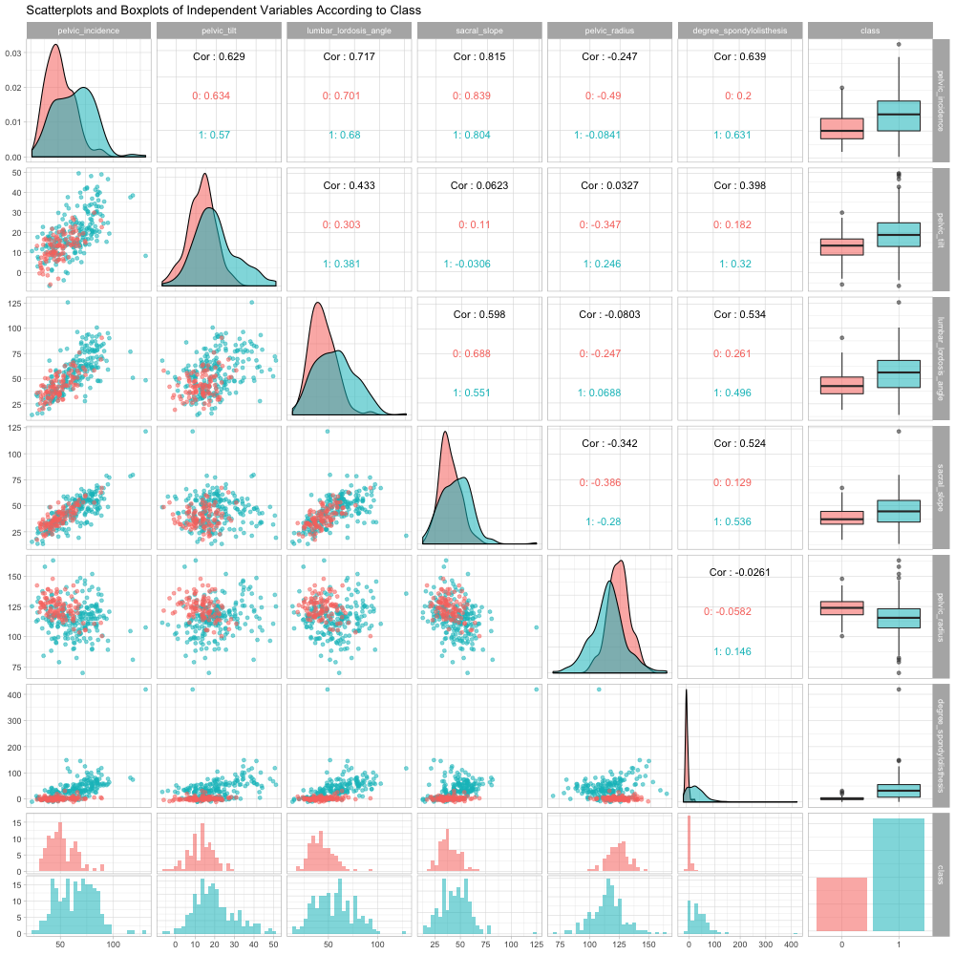

The above plot shows 15 scatterplots between 6 independent variables, and 6 boxplots for each independent variable, with blue indicating class 1 and red indicating class 0. Histograms, density plots and correlations are also shown.

(c) ii.

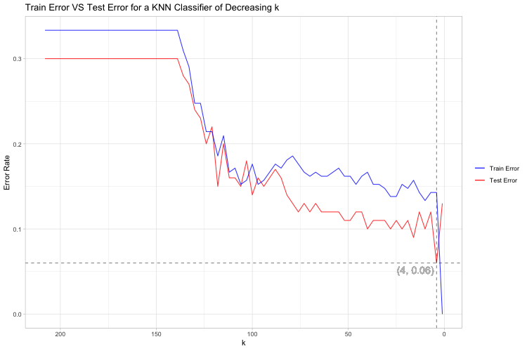

We can see that from the above graph, the lowest test error rate 0.06 is achieved when k is 4.

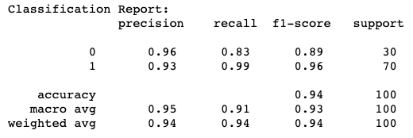

For k = 4, precision = 0.94, recall = 0.94, f1-score = 0.94.

We have true negative count = 25 and false positive count = 5.

True negative rate is given by TN / (TN + FP), and thus it’s equal to 0.833.

(c) iii.

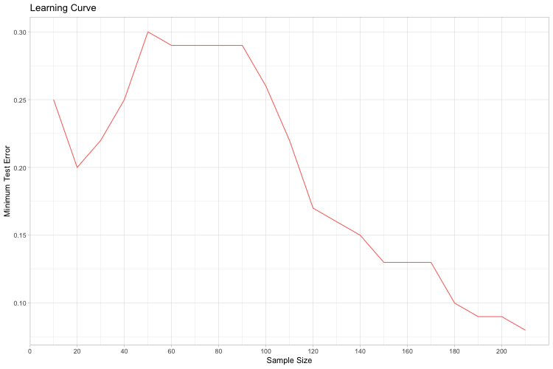

From the above learning curve, we can see fluctuations in minimum test error when sample size < 90. However, the minimum test error decreases steadily thereafter, achieving the lowest at 0.08, when all sample are used.

(d)

|  |  |
| --- | --- |
| **Metric** | **Best test error** |
| Manhattan Distance | 0.11 |
| Minkowski p = 0.2* | 0.11 |
| Chebyshev Distance | 0.08 |
| Mahalanobis Distance | 0.19 |

* The best log10(p) are when p = 0.2, 0.8, 0.9 or 1, using k = 11.

The Chebyshev Distance produces the lowest best test error.

(e)

|  |  |
| --- | --- |
| **Metric** | **Best test error** |
| Euclidean Distance | 0.10 |
| Manhattan Distance | 0.10 |
| Chebyshev Distance | 0.11 |

The three distances give similar result for weighted decision.

(f)

The lowest training error rate obtained is 0. This is achieved whenever n = 1, in which the nearest neighbor of every point to be classified is itself, leading to a error rate of 0 naturally.